

So here it is, the first Billitin for this illustrious year of 2016. Many of you will be new to this hallowed document, many of you will not understand the wonders it can yield. To those people I say bonne chance! The Billitin is on the face of it a simple bulletin, with information pertinent to the many and varied lives we Brucies Lead. However it has the potential to be so much more, as I hope you all discover over the course of this year. So without further ado I would like to welcome you to 2016!

.

*Doing it for Bill since 2014*

THE BRUCE BILLITIN

**ISSUE 01: Saturday 6th February- Sunday 14th February**

*Doing it for Bill since 2014*



BRUCE HALL: An interactive Guide

Even if you didn't have one, trust me this is better than that would have been!

Bruce Hall is a beautiful, bizarre, bountiful, bootylicious and brilliant place. In order to navigate life at Bruce, there are a few things that are useful to know. Firstly (and in my humble opinion most importantly) meal times:

**Breakfast**Weekdays: 7-10:30am (Hot breakfast available 7:30-9:00)

Weekends: 7-10:30am Hot and regular Breakfast

**Lunch**

12:30-2pm

**Dinner**

5:30- 7pm

Furthermore we have two very important rules at these mealtimes:

1. Don’t comment on other people’s plates of food
2. Maximum 8 people per table, we want to make sure no one sits alone this week, so sit down wherever you want!

Laundries are located in West wing, opposite Central and On the bottom floor of North wing.

Furthermore we have a noise curfew, which starts at 11pm, so if you are up past this time (which I hope you will be at least once this week!) please respect your neighbours and try keep the noise down.

If you have any issues whatsoever don’t hesitate to ask your SR or a nearby CRC member. If you can’t find any of these people, then there is always a Duty SR who you can call. The number for this is: **6125 6015**

SCHIMDT HAPPENS- What’s on in ANU

Now Bruce Hall isn’t the only place which is doing something for O-week (but let’s be real, ours is the best), so if you have a hankering for something different, then there is plenty on around the university. Most of these events can be found in your O-week Guide, however if you are interested in finding out more head to these websites:

* **ANU Student Association events**: <http://www.anusa.com.au/>
* **ANU wide events and Academic Orientation details**:

http://www.anu.edu.au/students/get-involved/anu-orientation-week

**There have a couple of changes to event times as put up in the guide and on the boards:**

1. **The Compulsory Underage talk is at 10am on Sunday (NOT 9am Monday)**
2. **The Compulsory International Student meeting with Rochelle is at 9:30am on Tuesday**

*As we look ahead into the next century, leaders will be those who empower others-* Bill Gates



**A MAP OF BRUCE**

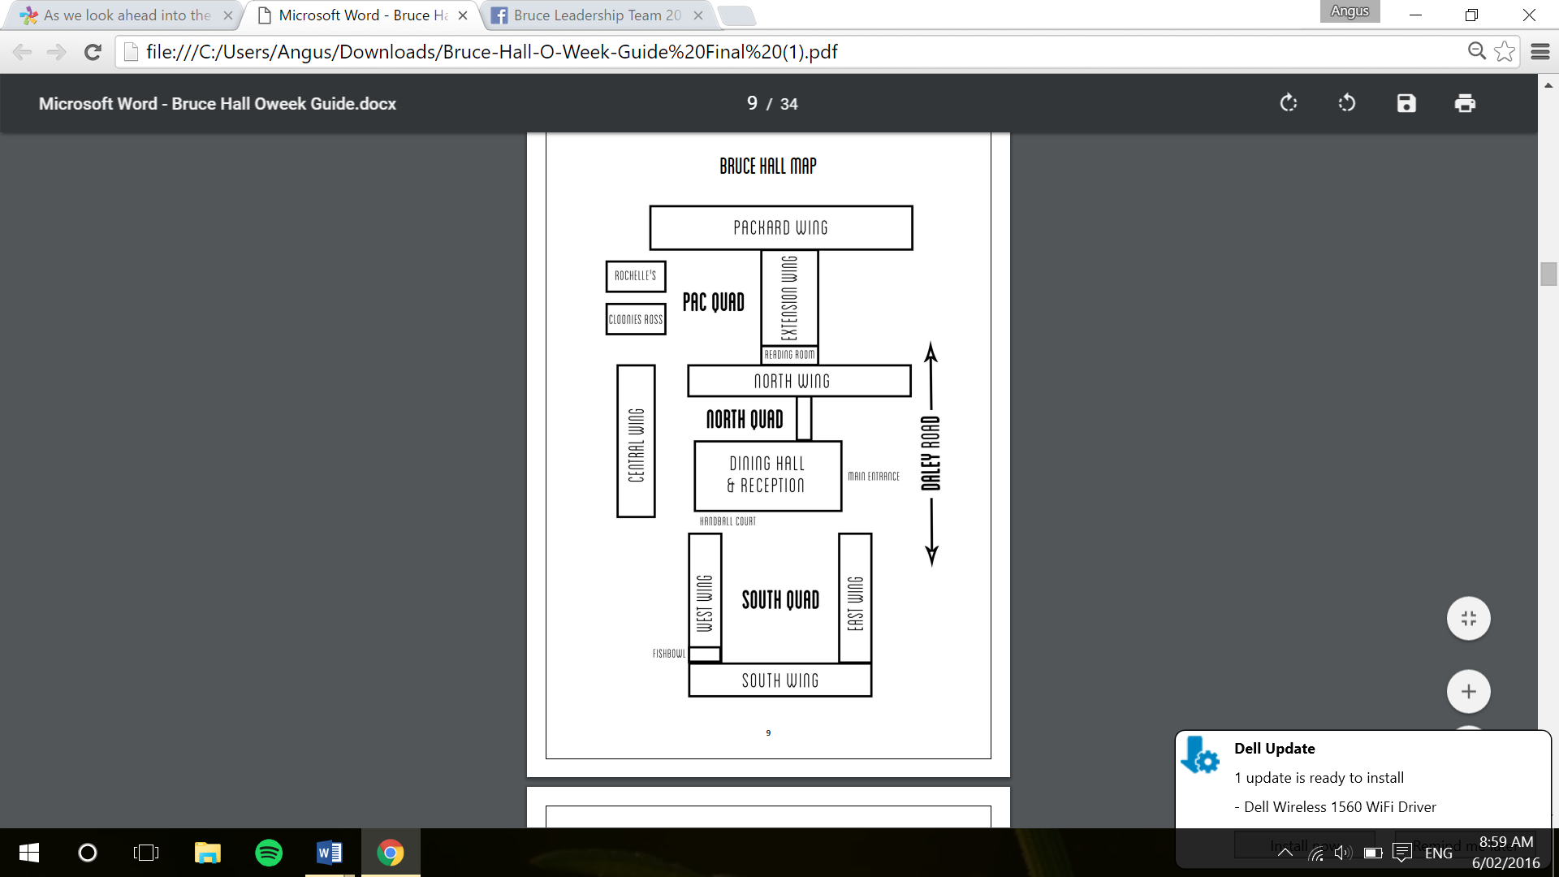



**Just Remember however that the name of the game this week is enthusiasm, and the best way to get to know people and have an awesome week is to get involved in as much as you can. So come on down and join us!**

TRIVIA

1. What year was Canberra designated as the capital? 7. What is the name of the creek running through ANU?

2. Who founded Bruce Hall? 8. How many heads of Hall has Bruce hall had?

3. What is the Bruce Hall Mascot? 9. Who is the Vice chancellor of ANU?

4. How many pictures of Ourobouros are there around Bruce Hall? 10. What is the first event on the ANUSA O-week calendar?

5. What is the name of the road leading straight to Union Court?

6. How Many days of the year did the House of Representatives sit  
 last year?

1. 1913, 2. Bill Packard 3.A Blue Dragon, 4. 4 5. University Avenue, 6. 60, 7. Sully’s Creek, 8. 7, 9. Brian Schmidt 10. Free Yoga on University Avenue, 8am Monday.